# CS 255 System Design Document Template

## UML Diagrams

### UML Use Case Diagram

### UML Activity Diagram For Login/Register Use Case

**UML Activity Diagram For Update DMV Standards**

### UML Sequence Diagram

### UML Class Diagram

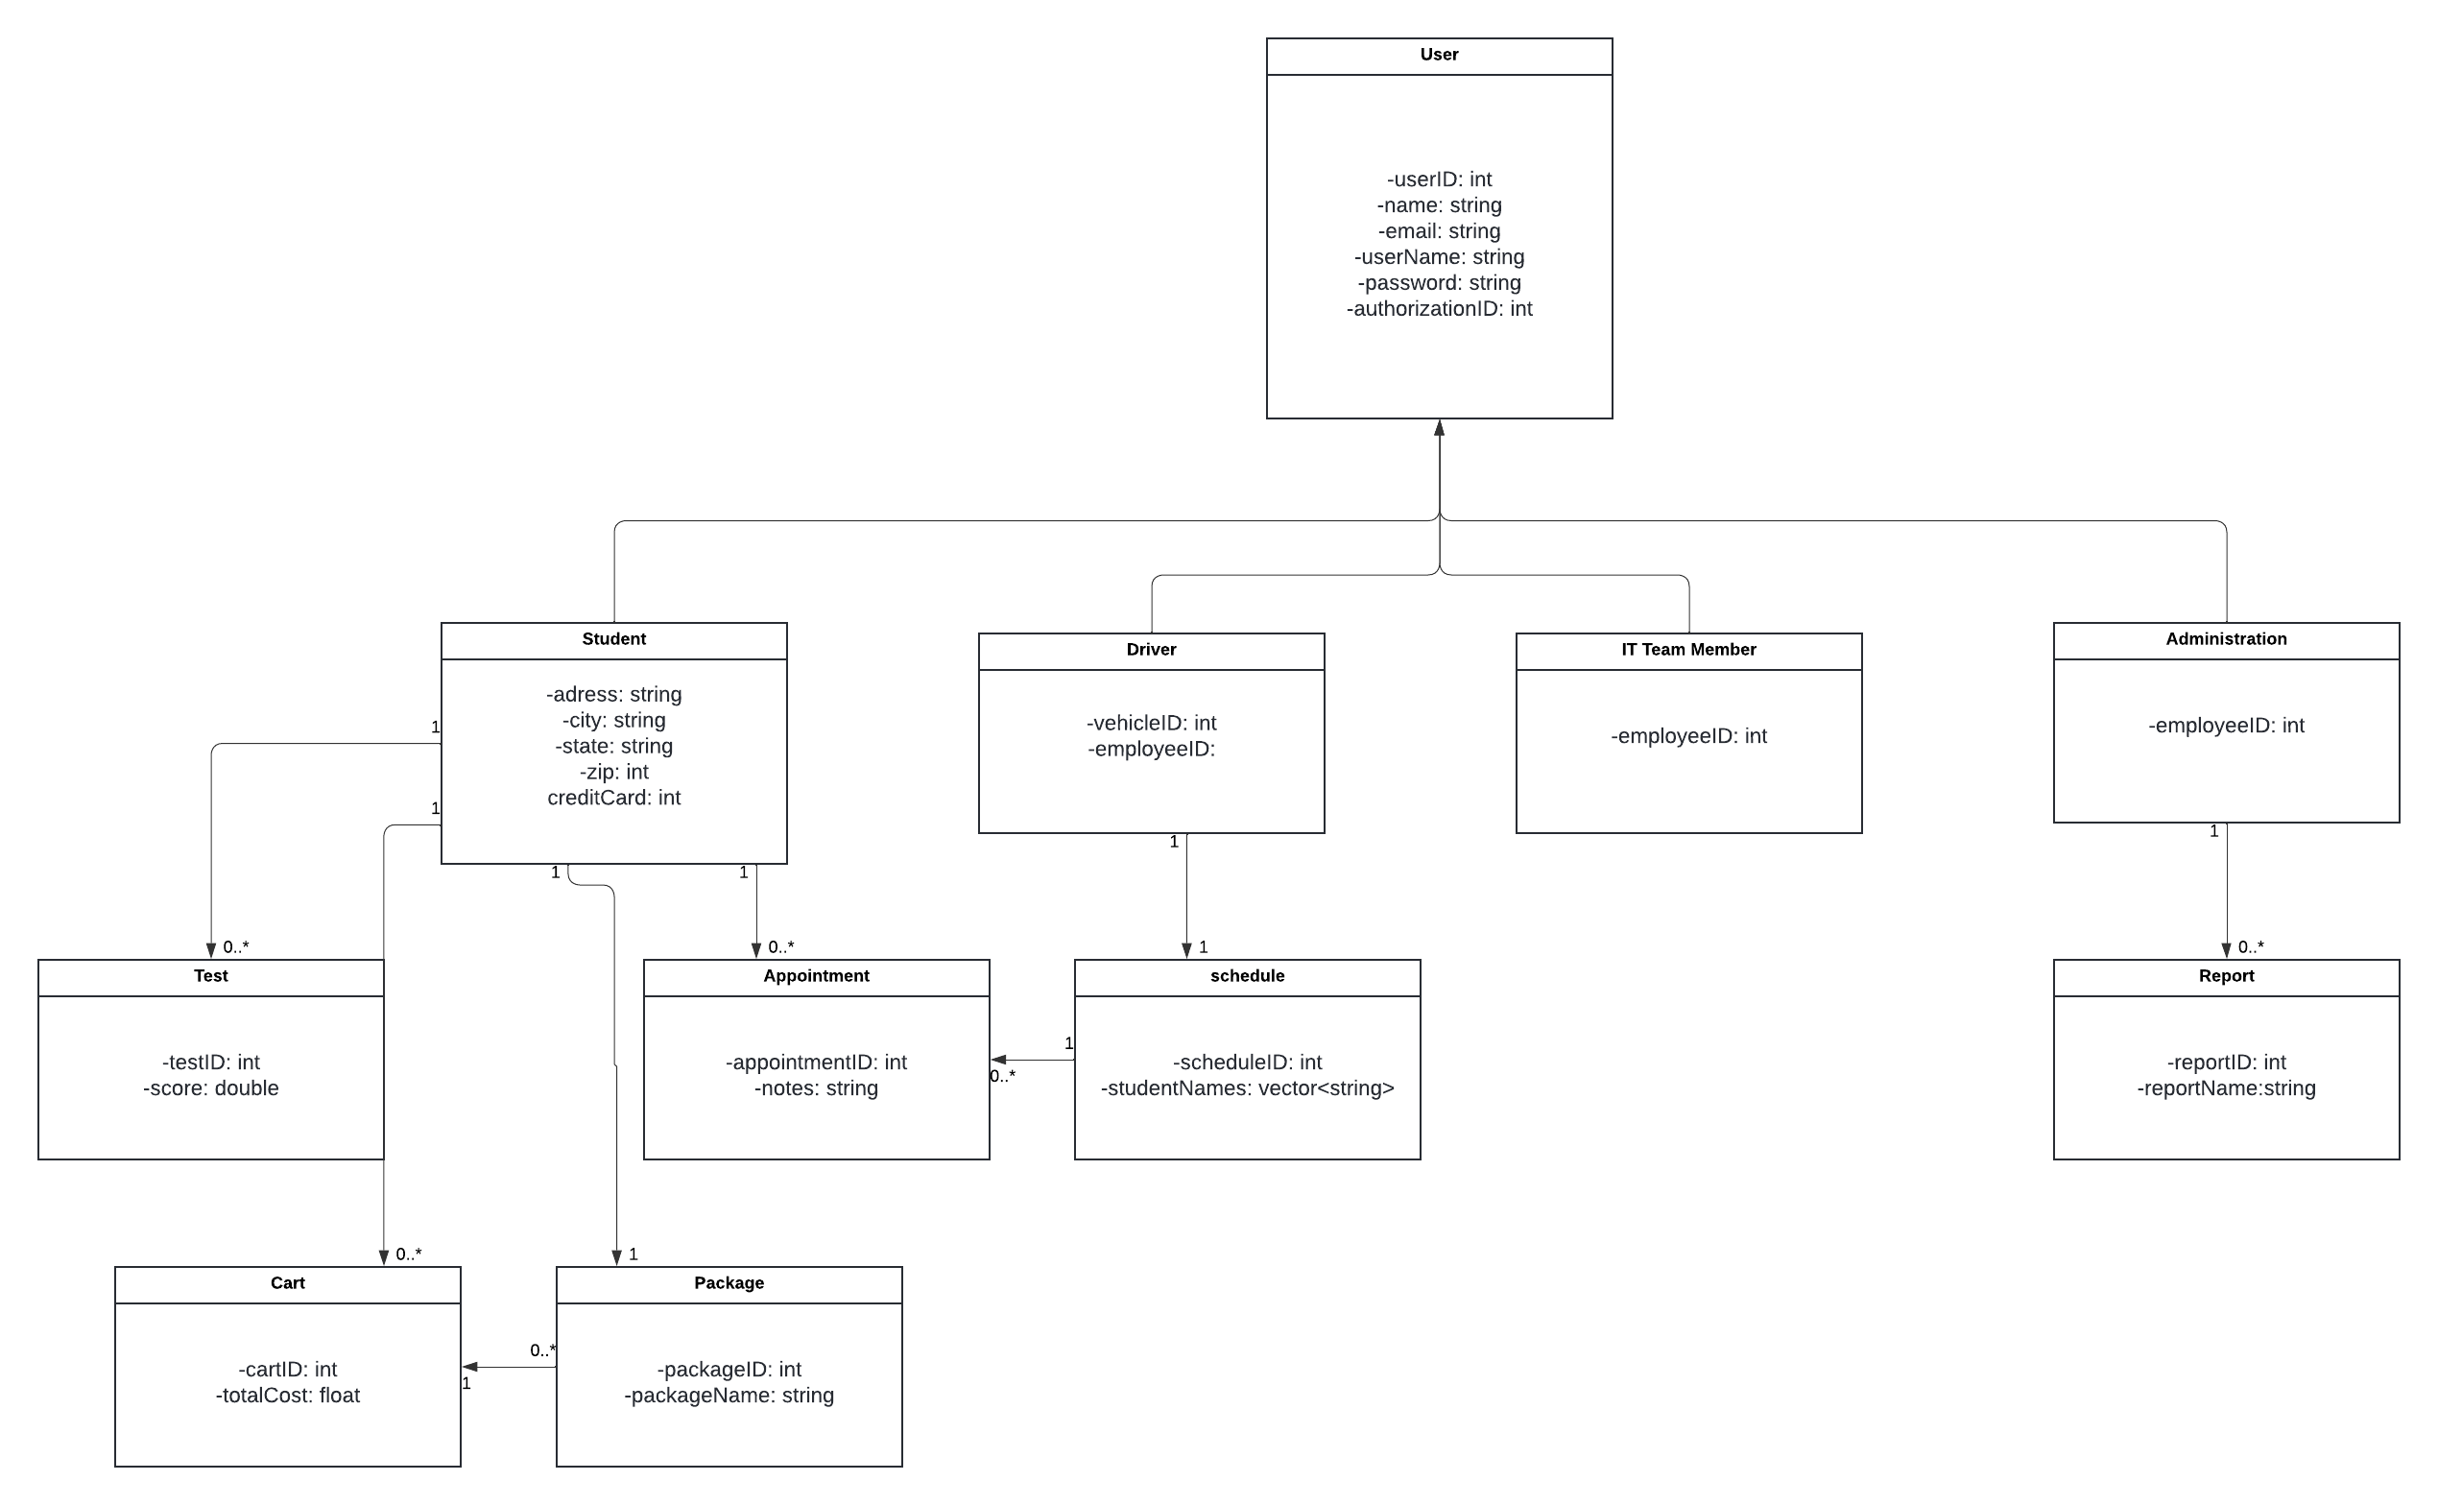

## Technical Requirements

* Hardware
  + Dedicated Server
  + SAN for storage
  + Computer and Mobile devices for accessing website
  + Firewall to protect data
* Software
  + Windows server
  + SQL server for database
  + Backup software for database
  + Antimalware/virus software for all computers
  + Apache
* Infrastructure
  + Data center for storing database and website hardware
  + Main office building